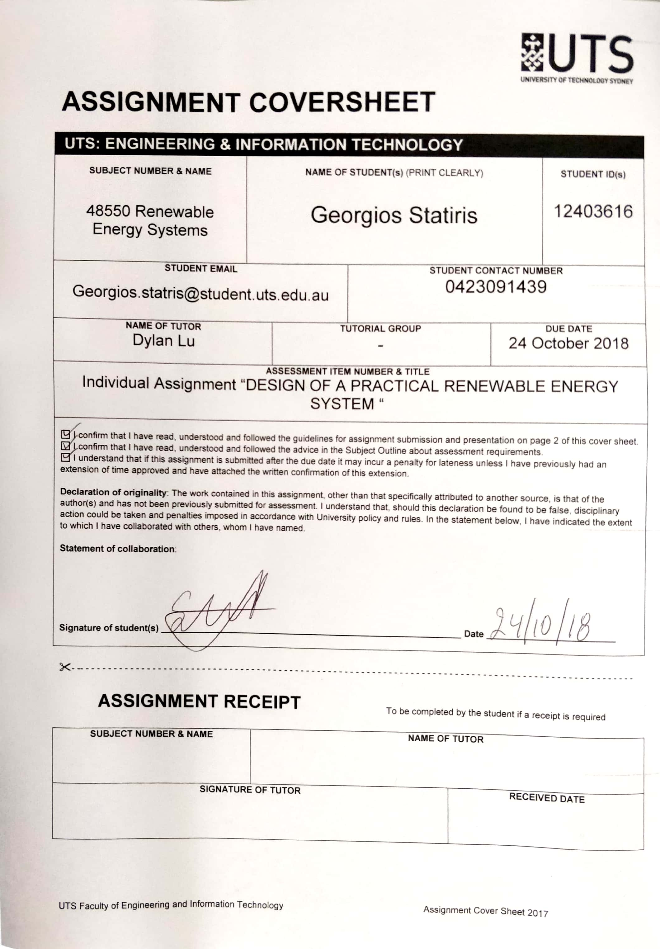

Individual assignment for   
48550 Renewable Energy Systems   
Spring 2018  
“DESIGN OF A PRACTICAL RENEWABLE ENERGY SYSTEM”

Georgios Statiris S.N:12403616

*Abstract*—In this paper, a need for a new Renewable Energy Source in the area of Wollongong is identified. The speed wind in the location is analyzed and a place for the wind farm to be built is specified. The chosen model of wind turbine is specified, and energy output is calculated.

*Index Terms*—Renewable energy, wind turbine, offshore wind farm.

# Introduction

T

HIS document is a proposed design for a practical renewable energy system. The location has been chosen to be Wollongong and the Renewable Energy Source is wind. In the next sections, I will analyze the design criteria and characteristics including energy output calculations and cost estimation.

# Location

In order to find where the best location is to install our wind farm, we need to analyze the wind intensity of various areas. To analyze the availability of wind, we investigate the kinetic energy of the area.

In the figure below is shown the mean annual wind speed for a part of NSW for both onshore and offshore locations. It is measured at 100m above ground (hub height; not including the height of the wind tower with the blade), which is an average height used for modern wind turbines.

It is clearly seen that the intensity of wind is very high, inside the ocean, where there is open space and free from obstacles such mountains, buildings, trees etc. The speed there reaches the mean values of 10.2 m/s [1].

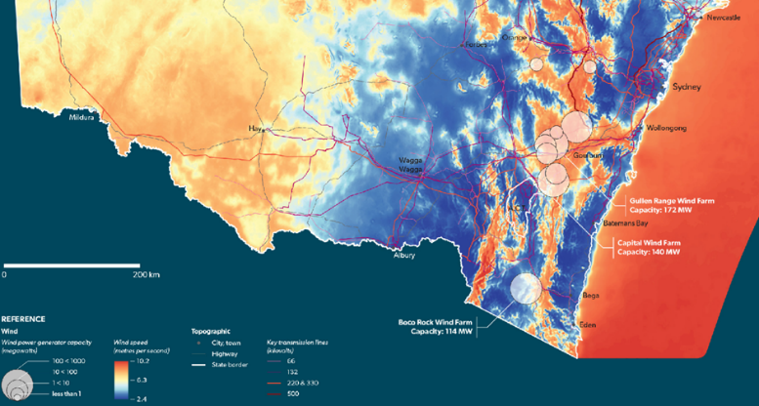

Figure 1 Wind Intensity heat map

So, I have come to the conclusion to analyze the establishment of an offshore wind farm, 10-20 km away from the shore, somewhere between Newcastle and Batemans Bay, allowing us to get a constant and efficient power generation plant, with not too high maintenance needed.

Another alternative that was investigated, was to install the windfarm in the open waters of Queensland, 10-20km in the sea somewhere between Cairns and Townsville, where according to Australian Bureau of Meteorology, average wind speed from March till July reach up to 35 m/s, and extremely high speed that can produce tremendous amount of energy [2].

This is alternative was not chosen for this report, because as it will be shown later on, population and energy demand in NSW is increasing dramatically and expected to keep increasing in the next 20-30 years.

Although, it could be possible to generate the electricity up in Cairns and then build long transmission lines for energy to be used in Sydney. That scenario would increase the cost of the project a lot and the duration would be much longer.

# Energy Demand

Using information provided by the Australian Department of Environment and Energy, I was able to compare how much of the total energy produced in each state is coming from Renewable Energy Sources [3]. I then summarized the results in the graph below.

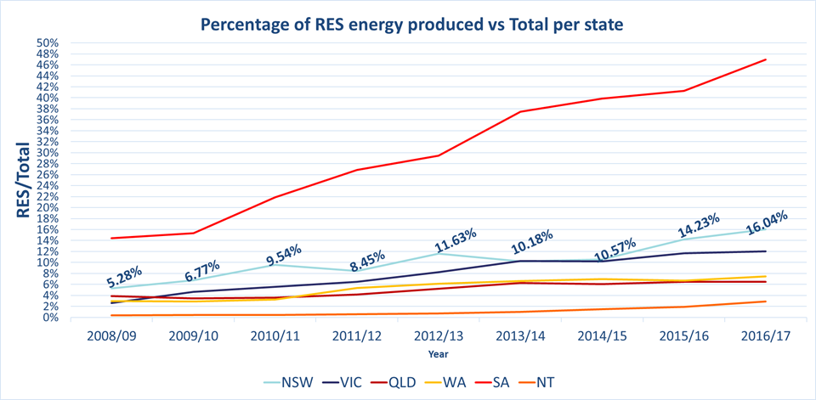In the graph I am not including Tasmania, where the ratio of RES/Total Energy has been around 90% the last 10 years.

Figure 2 Res vs Total energy produced

Looking at the graph above, it is seen that the generation of Renewable Energy is increasing in all states and especially in QLD and NSW, where the population has been growing much faster than the other states.

In the next 20 years the Australian Government is aiming to increase this ratio even more, meaning that Energy generation by burning black coal will be replaced by different types of RES for a green and sustain environment.

As of 18 March 2018, NSW is the state with the highest population, reaching 7.95 million residents but also with highest population growth rate, growing by roughly 106,100 people per year [5].

According to Planning and Environment, the population of NSW is expected to reach 9.9 million by 2036[5]. Thus, it is expected for the energy consumption of NSW and more specifically metro areas, to increase their energy demand, and so the need for even more energy production arises.

We shall prepare and start finding new ways of producing electricity, in order to stop using harmful to the environment sources such as black coal, Natural gas and Oil products.

In my design, I am choosing to supply the generated energy to the area of Wollongong. After doing a research and analysis I have to the conclusion because of the following key points:

• The current population of Wollongong at the moment is around 216,375 and is expected to reach 254,805 by 2036. [4]. That is a 17.76% increase of population in just 18 years.

• The household count in Wollongong at the moment is estimated to be 83,540 and excepted to rise up 99,755 by 2036. [5]. That translates to 16.25% increase in households.

• Average of 2.5 people share a house in Wollongong [6].

While doing some research, I found a tool provided by the Australian government [7] that lets you estimate the yearly energy consumption for a household in a specific area. After choosing postcode 2500 (Wollongong) I got the following results

Table 1 Average Energy consumption calculation

|  |  |  |
| --- | --- | --- |
| People leaving in the home | Average Energy Consumption Daily | Average Energy Consumption  Yearly |
| 2 | 14.1kWh | 5,141kWh |
| 3 | 14.8kWh | 5,396kWh |
| **2.5(Wollongong average)** | **14.5kWh** | **5,268kWh** |

Now I have calculated that the average consumption for a home in Wollongong is approximate 5,268kWh per day. That is relatively small amount of energy consumption, and that is because there are mostly only 2 or 3 people leaving in home in Wollongong and mostly they are apartments, but also the fact that it doesn’t get too cold in winter neither too hot in summer, so residents consume less energy for heating up or cooling down their homes.

We can now predict how much the energy demand is going to increase in the 18 years. Calculations are shown below:

Average Energy demand of a household in the area = 5,268kWh   
Approximate home count in Wollongong 2018 = 83,540  
Estimated home count in Wollongong in 2036 = 99,755

Table 2 Calculation of energy demand increase

|  |  |
| --- | --- |
| Approximate Energy consumption by  homes in Wollongong in 2018 | 5,268kWh * 83,540 = 440,088,720 kWh = 440,089MWh = 440.1GWh |
| Approximate Energy consumption by  homes in Wollongong in 2036 | 5268kWh * 99,755 = 525,509,340 kWh = 525,509MWh = 525.5GWh |
| Approximate Energy **demand increase** in 18 years in Wollongong | 525,509,340 kWh - 440,088,720 kWh = 85,420,620kWh = **85.421GWh** |

I have now calculated that the yearly demand will increase in the 18 years by approximately 85.421GWh.  
So, our need and goal is to construct a wind farm that will be able to provide Wollongong with extra energy to reduce the gap between increased demand and the energy generated now.   
The project will be split into two phases. Phase A will be to design and deliver by 2020 a wind farm that will generate half of the estimated growth in energy demand. Phase B, will be to investigate the efficiency of the first wind farm of Phase A, and establish a second and improved windfarm of the same capacity in 2030. The reason of splitting the project in two phases, is because if we don’t, the demand now will be much less than the energy generated and even though we will have batteries for storage, there will be tremendous amounts of energy waste.

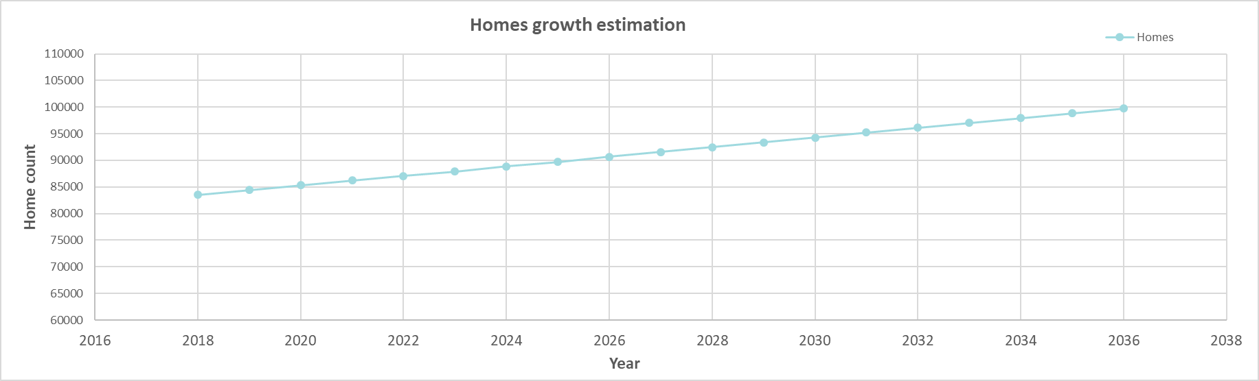

Figure 3 Wollongong number of homes growth

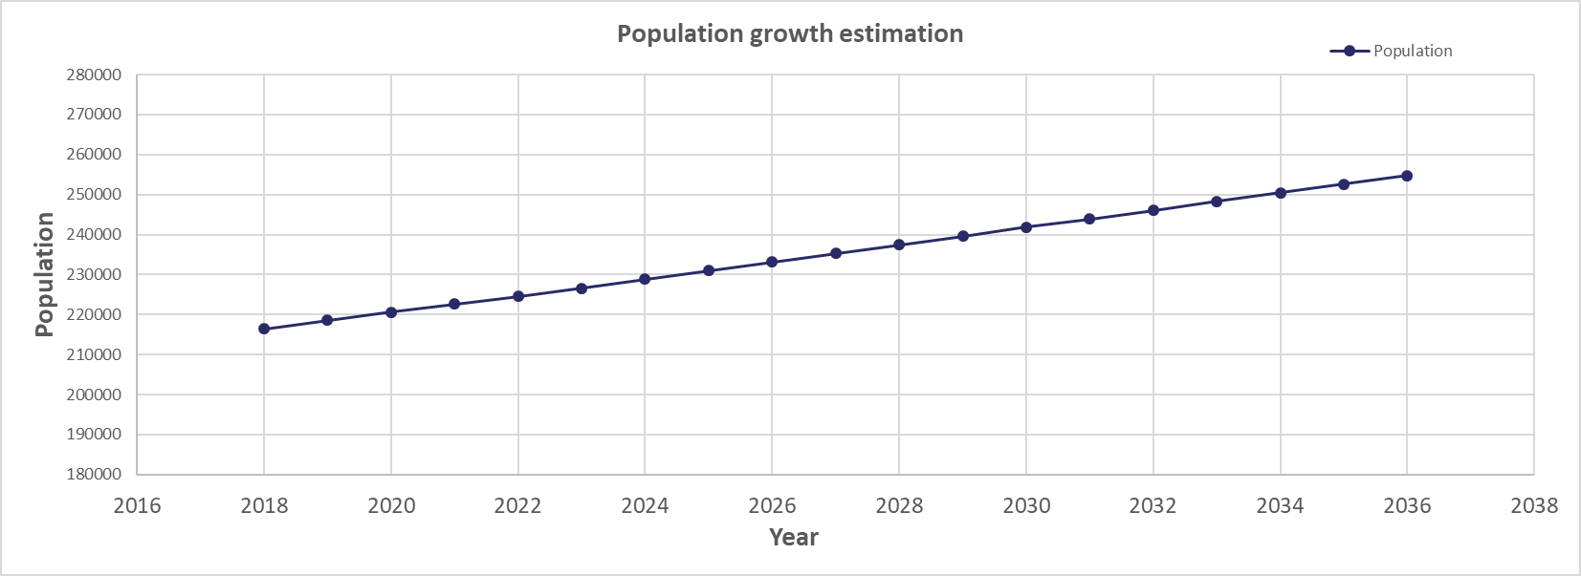

Figure 4 Wollongong population growth

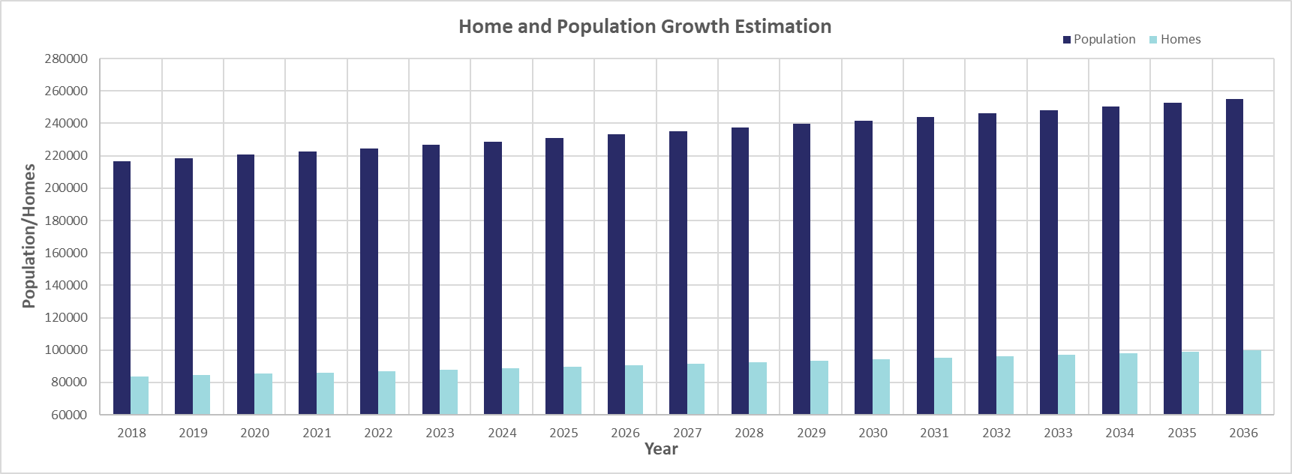

Figure 5 Wollongong homes and population growth

# Renewable Energy Source (Wind)

Over the past decades due to the rapid technology evolution, has promoted the use of Renewable energy sources and more specifically, wind energy. Now days we can use stronger materials and thus build higher wind towers which produce more energy and together with the evolution in power electronics, we are able to store a lot more energy to use it in the future.

All over Australia, in 2017, wind energy was 33.8% of the total clean energy (renewable) produced and 5.7% of Australia's overall (both non-renewable and renewable) [3].

While in NSW only 2.10%(1.492 of 71,007 GWh produced) of the total energy (which translates to 16.75% of the total Renewable Energy Sources’ energy generation) comes from wind, there are high potentials and many wind farm projects are already undergoing. Advanced new technologies, such as better manufacturing and electronics, have increased the power generation to 4 times bigger and have dropped down the cost (cents/kWh) significantly and it will be even more efficient and cheaper in the near future.

## Capacity Factor

Using wind to produce electricity can be much more efficient than other Renewable Energy sources because wind blows 24 hours a day and 365 days a year, which means that under ideal conditions, it is possible to produce electricity for the most part of the year. However, windfarms only operate at a fraction of their capacity. That is described as the **Capacity Factor** of the powerplant. If for example, we install 20 wind turbines of 7MWh capacity each, the windfarm’s capacity is 140MWh. That means it can theoretically and under ideal conditions generate 140MWh (140 MW per hour).   
Although, power wind farms usually generate around 20-40% [22] of their capacity, and a study from the Australian Energy Council showed that in 2015-2016 the capacity factor of wind farms(onshore) in NSW was 32% [12]. This is expected to be close **to 39%** for an offshore wind farm, where the wind speed has a higher mean value.

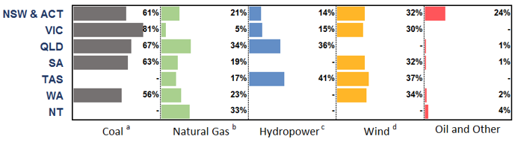

Figure 6 Capacity factor Australian power plants

A proof to this study can be found below, where as you can see, the wind farm in Boco Rock NSW on 11/Oct/2018, had an actual/live capacity factor of 30%, which means that the power plant generated 34MW of the maximum possible (113MW) [22].

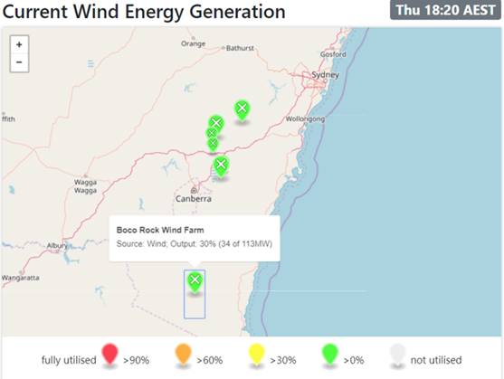

Figure 7 Capacity factor NSW power plants

By choosing the appropriate location, direction-angle, model and height of the towers, and by creating an efficient power transformation system (transformers, grid lines etc.) we aim to build a wind farm with the highest efficiency possible. Once a wind farm is built, it can be very efficient and cheap to produce electricity and to be maintained.

## How it works

Wind turbines use the kinetic energy of the wind to spin the blades which then start the rotation of a shaft (Kinetic energy🡪mechanical power).   
This shaft powers a generator which by the principal of electromagnetic induction generates electricity (Mechanical power🡪 Electrical energy) [11].  
Transformers are then used to increase the voltage (step-up transformers, usually located in the bottom of the tower) and then the generated energy is delivered through buried cables to a substation (either onshore or offshore). From there, depending on the location of the substation, short, medium or long transmission line are used to deliver energy to consumers.

*How* ***offshore*** *wind turbines work:*

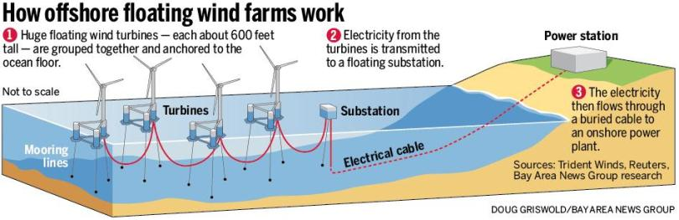

Figure 8 Offshore wind farm diagram

## Design system topology

As also seen tin the picture below, a wind turbine consists of the following main components:

* Tower and blades
* Nacelle cover, which is the housing for the most parts of the wind turbine
* Electrical generator
* Main shaft
* Yaw mechanism
* Gearbox, cooling system and control system

### Type

There are many different types of wind turbines and of different shape. Usually they have 2 or 3 blades and can be upwind (facing into the wind) or downwind (facing away the wind) [10].

While there are both horizontal-axis wind turbines (HAWT) and vertical axis wind turbines(VAWT), the first ones are most commonly used. Below are attached the advantages and disadvantages of both types:

HAWT are suitable for both small or large systems, such as using one tower to power a portion of building or a designing wind farm to power a village.

* Advantages: Very efficient; can be built very tall, targeting very high wind speeds
* Disadvantages: Complex system; Installation cost is high because the generator and gearbox need to be installed on top of the tower.

VAWT are usually used and most suitable for small systems (like for example UTS Building 11)

* Advantages: much cheaper; the gearbox and the generator can be installed on the ground; unlike HAWT, they don’t need a yaw system to constantly turn the rotor against wind.
* Disadvantages: Less efficient because mean value of wind speed is much lower near the ground; may need guy wires; requires more frequent maintenance

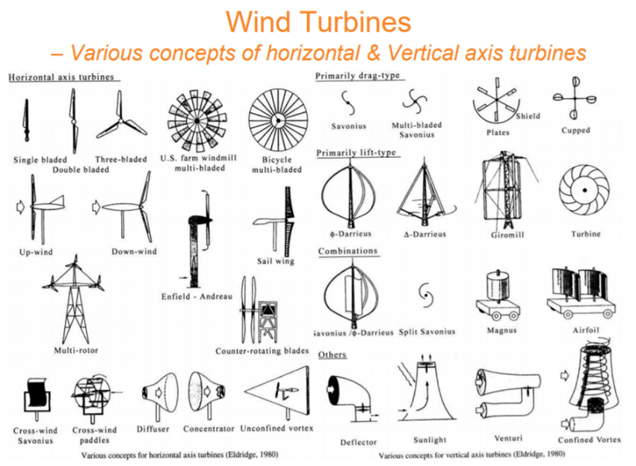

Figure 9 Types of wind turbines

### Number of blades:

Most of the wind turbines designed and manufactures today have 3 blades as a standard [10].   
After doing some research, below are mentioned the main advantages or disadvantages of each possible design:

* 1 blade design: would have been the most efficient when it comes to energy yield [10] but having only one blade, could cause an unbalanced situation in the system, and the turbine would become unstable
* 2 blades design: would also have a better energy yield than 3, but this design is more prone to a phenomenon known as gyroscopic precession, resulting in wobbling, creating instability to the turbine and reducing the effectiveness of it as well as causing the turbine to wear down over time [10].
* 3 or more blades design: this would increase the resistance of the wind, eventually resulting in slower rotor rotation and thus less energy generation and efficiency of the turbine.

### How wind speed is affected from height and terrain

It is a scientific fact that on planet earth, the higher you go from ground to the atmosphere (and also the more open the area), the higher the wind speed will be. That is due to the fact that the density of the air is decreasing the higher you go, and wind needs less force to travel distances, so it travels faster.   
For this reason, we are going to design our wind turbines’ hub height to be 100m tall (101.5m to be more specific) with a big wind span. It is always better to go higher, but because our wind turbines will be imported from overseas and for the logistics to be feasible, faster and cheaper, we are choosing 100m which is a typical turbine height and feasible to transport.

Furthermore, the benefit of having an offshore wind farm is that there no obstacles like mountains, building, trees etc. which create friction and reduce the wind speed.

When calculating the variation of the wind speed versus height, we need to consider this friction, by including in our calculations the Friction Coefficient α.

Table 3 Friction Coefficient

|  |  |
| --- | --- |
| Terrain Characteristics | Friction Coefficient α (approx.) |
| Smooth hard ground, calm water | 0-0.10 |
| Tall grass on ground earth level | 0.15 |
| High crops, hedges and shrubs | 0.2 |
| Wooded countryside, many trees | 0.25 |
| Small town with trees and shrubs | 0.30 |
| Large city with tall buildings | 0.40 |

If we now want to calculate the variance of speed versus height we can use the following formula:

$$V_{2}=V_{1}{\left(\frac{h_{2}}{h_{1}}\right)}^{α}$$ where:

$$V_{1 }\left(\frac{m}{s}\right)h_{1}=10meters \\ V_{2}\left(\frac{m}{s}\right)→speed of wind at {height h}_{2} \\ α→ friction coeffecient of surface$$

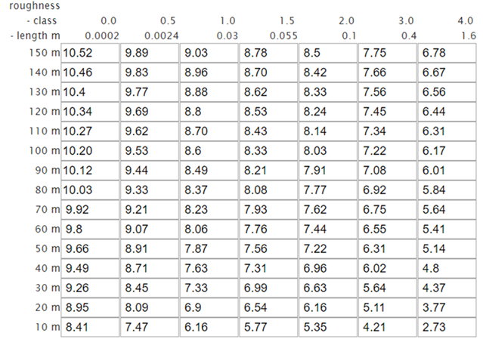Below are attached the obtained results of wind speed for different height and also different coefficient.

Table 4Wind speed vs height vs α

It is worth mentioning that for an offshore wind farm, the friction coefficient of the surface is close to 0 [21].

From the results above, we see that for α=0, if the hub height of the wind turbine is 50m, the mean wind speed is $9.66 m/s$ while at 100m it is increased at $10.2 m/s$, thus generating more energy.

### Choice of model

Taking into consideration all of the above, we have come to the conclusion that, **for our design**, the turbines will have 3 blades and be of 100m hub height (101.5 to be accurate).  
Also, following the investigation on the axis direction, the turbines will be of Horizontal design (HAWT), because we need them to be very tall and strong to withstand the strong wind currents that often occur in the ocean.  
We have chosen Siemens to be our supplier for the wind turbines, and more specifically we recommend the establishment of a **27 units (phase A)** wind farm, of the model **SWT-7.0-154**, with the following characteristics [13]:

Table 5 Wind turbine specs

|  |  |
| --- | --- |
| **Siemens SWT-7.0-154** | |
| Type | 3-bladed, horizontal axis |
| Nominal Power | **7.0MW** |
| Blades | **75m** |
| Rotor Diameter | **154m** |
| Rotor tilt | 6 degrees |
| Swept Area | 18,600m2 |
| Position | upwind |
| Power Density | 253.2 W/m2 |
| **Generator** | |
| Type | Synchronous, PMG, **direct drive** |
| Voltage | 690 V AC |
| Frequency | 50 Hz/60Hz |
| Protection class | IP 54 |
| Power factor | 0.925 CAP – 0.925 IND |
| **Yaw System** | |
| Type | Active |
| Yaw bearing | Externally geared |
| Yaw drive | Electric gear motors |
| Yaw brake | Passive friction brake |
| **Operational data** | |
| Cut-in wind speed | **3 - 5 m/s** |
| Nominal power at | **13 - 15 m/s** |
| Cut-out wind speed | **25 m/s** |
| Maximum 3 s gust | 70 m/s (IEC version) |
| Cut-in wind speed | 3 - 5 m/s |
| Nominal power at | 13 - 15 m/s |

# Energy output

To obtain the estimated daily output in KW for the windfarm, we need to multiply  
the **daily capacity of the wind** farm by the **Capacity factor** that was obtained to be 0.39 in previous sections by **the amount of wind turbines** by **the number of hours in a year** that the wind turbines were operating. To estimate the number of hours the wind turbines were operating in the year, we will use the Weibull Distribution and by using the online tool of the Danish Wind Industry Association and by putting in the appropriate parameters according to our design, we get the following results [21]:

Table 6 Calculation of Energy Output

|  |  |
| --- | --- |
| **Energy Output calculation** | |
| Number of wind turbines: 27  Capacity each: 7.0MWh | |
| Total Capacity: 280MWh | |
| Estimated Energy generated/year/turbine | 1,632,799KWh =1,633MWh |
| Total Wind Farm Energy Generation in a year  =1,633MWh*27= **44.085GWh/year** | |

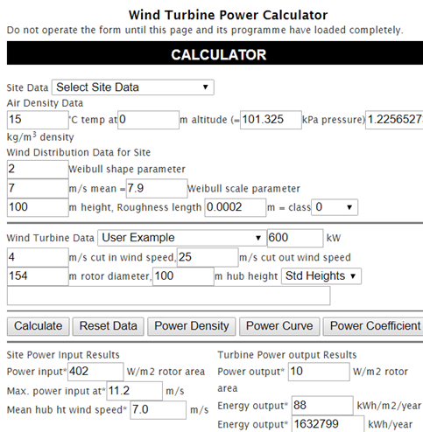

Figure 10 Energy output for wind turbine

As seen above, it is calculated that for the Phase A of this project (installation of 27 wind turbines in 2020), the estimated energy generation is around 44GWh/year.   
If we look back, we calculated that the energy demand is going to increase by approximately 85GWh/year in 20 years.

Thus, our Energy Generation calculations show that in Phase A of the project we are covering 51% of the energy demand’s increase, which is exactly what we wanted, leaving us with the 49% for Phase B.

In the energy demand section, it was calculated that the average household in Wollongong consumes 5.268MWh in a year. That means that our Phase A power plant will produce enough energy to provide electricity to:

$$\frac{energy produced/year}{average house use/year}=\frac{44.085*{10}^{9}}{5.268*{10}^{6}}=8368 homes$$

And if we time this by 2, we calculate that Phase A and Phase powerplants will produce enough electricity to provide 16,736 homes in Wollongong, which is very close to 16,215 which, as mentioned in energy demand section, is the estimated household increase in Wollongong by 2038 [4]

# Battery/Energy storage

The electricity grid and transmission system is a complex system, where the demand of energy needs to be equal to the power supply at all the times.   
Although, neither the energy demand nor the power supply is always constant. For example, between nights’ time the energy demand might be less than days’ time and between summer and different hours of the day the wind speed (hence the power generation) is also alternating.  
To balance this, we need to include in our design an energy storage system, which will use the stored electricity to support the grid when the demand is higher than the supply (**discharge of storage devices**) and on the other hand, when the demand is lower than the supply, the excess electricity is used to power the storage devices (**charge of storage devices**) [16]. This will allow the government of NSW to store the energy when the price is low and sell it when the price higher but in a lower price than before, making extra profit for the state but also reducing the consumer’s expenses.

There are many different types of energy storage such as: pumped hydroelectric storage, thermal storage, compressed air, hydrogen, batteries and more.   
Following South Australia’s new battery storage projects, we are proposing to use in our power plant, lithium ion battery storage, supplied by Tesla (in partnership with NEOEN) due to the following advantages [17]:

* fast and simple installation process
* scalable flexibility
* durability
* small size compared to other grid-scale energy storage solutions
* high efficiency (up to 90-95%)

For storage durations of 30 minutes to three hours, lithium batteries are currently the most cost-effective solution, and have the best energy density compared to the alternatives [15]. Like all other batteries, lithium ion batteries consist of generating compartments called cells. Each cell is made of a positive electrode (anode), a negative electrode (cathode) and an electrolyte between them. For the battery to charge, the positive 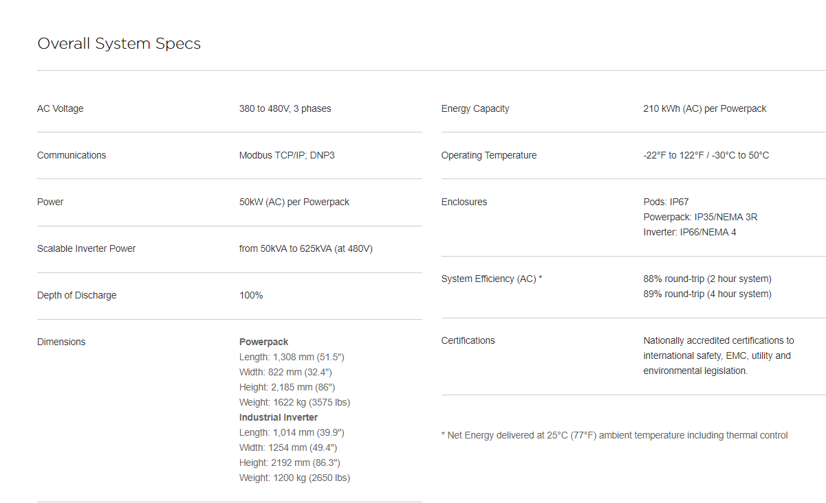electrode gives, through the electrolyte, some of lithium ions to the negative electrode.

During this process the battery outsources the energy and it stores it internally. For the battery to discharge, the lithium ions move back, through the electrolyte, to the positive electrode. Both while charging and discharging, electrons don’t flow though the electrolyte but instead, they flow in the opposite direction to the ions around the outer circuit.

The advantage of lithium batteries is that it has a control system that regulates the charging and discharging process, preventing overheating and overcharging, and minimizing the risks of fire and explosion.   
After doing dome research, I am proposing to follow the exact same design as the Horsndale Power Reserve (129MWh) following the study that showed that “Revenues in the first 6 months amounted $17(USD) million (over 25% of the cost)!” [18]. The system is to be powered by 198 units of the following Powerpack to meed the specs:

## Overall system Specs

## Grid Interface

**Bi-Directional Inverter:** The inverter converts AC grid power to DC for Powerpack storage, then converts this DC power back to AC for grid interconnection

**Powerpack Controller:** This onsite computer interface creates control signals relays commands to the inverter and DV combiner based on integrate application control software, or control signals relayed from a SCADA system

**Software:** State of the art battery management software controls performance at the cell, pod and pack level. Built in control software enables dispatch from a locally hosted interface, a direct DNP3 connection and schedules or autonomous operation. No additional software or integration is necessary.

# Cost

After doing some research, I found out that for an offshore Siemens wind turbine of this type, it will approximately cost 1.17(million€)/MW = 1.89million(AUD$)/MW

$$Total approximate cost per turbine=1.89\left(million\$\right)*7=13.23\frac{million\$AUD}{turbine} \\ Total approximate cost of all turbines=13.23*{10}^{6}*27=357.21 million AUD$$

Other and total expenses [18] [19] [20]:

|  |  |  |
| --- | --- | --- |
| **Total project cost estimation (Phase A only)** | | |
| Expense | AUD/MW | Total(AUD$) |
| Grid Connection | 95,000 | 17,955,000 |
| Land | 200,000 | 37,800,000 |
| Logistics | 100,000 | 10,890,000 |
| Labor (Installation cost etc) | 10,000 | 1,890,000 |
| Energy Storage | - | 46,000,000 |
| Wind Turbines Cost | 1,890,000 | 357,210,000 |
| **Total** | | **471,745,000AUD$** |

# Conclusion

During this article, I have done an extended research on the generation of electricity using wind farms. My initial approach was to do a demand analysis and analyse the locations in Australia with the fastest growth and biggest need of energy. Once the location was determined, I investigated different types of powerplants that can be established. I initially started investigating Concentrated Solar Power, but then I came across with the statistics that showed how high the mean value of the wind speed is in the ocean across NSW. I then realised the enormous potential of a wind farm in that location and started doing research on that. I have not included any of the information I gathered on Concentrated Solar Energy because when I tried doing a quick comparison, I realised that I went much off topic.

To conclude, our design consists of 2 Phases, with each phase having 27 HAWT and 3-blade configuration wind turbines (Siemens SWT-7.0-154) and each phase covering approximately 50% of the increase in the energy demand in the next 20 years.   
  
Feedback:   
I found this assignment a very interesting task to work on. During my research I found many detailed information which I did not include in this report because I believed it was too much detail for the reader to read, and to me, that didn’t seem the scope of the assignment. For example, one interesting topic that I didn’t include is “How wind turbines are installed in the ocean”. I found out that the most common and quickest method is the “Driven Pipe Pile” which uses a hydraulic hammer to drive the Monopile in the bottom of the ocean.

It was a great semester and the course of RES, the stuff and the content went beyond my initial expectations.

# Acknowledgment

This is an individual research made by the author as a part of Renewable Energy Systems course. All references can be found in the next section.

# References

[1] NSW Government Resources and Geoscience 2018, Renewable Energy Resources of NSW, viewed 9 October 2018,< <https://www.resourcesandgeoscience.nsw.gov.au/__data/assets/pdf_file/0004/665527/RenewableEnergyMap2017_side-1.pdf> >

[2] Bureau of Meteology 2018, Wind roses for selected locations in Australia, Australian Government, viewed 9 October 2018, <[http://www.bom.gov.au/climate/a verages/wind/selection_map.shtml](http://www.bom.gov.au/climate/averages/wind/selection_map.shtml)>

[3] Department of the Environment and Energy 2018, Australian Energy Statistics, Table O Australian electricity generation, by fuel type, physical units <https://www.energy.gov.au/sites/g/files/net3411/f/aes-table-o-2016-17_2017.pdf>

[4] .id 2017, Forecast population, households and average household size, Wollongong City Population, households and dwellings, viewed 9 October 2018, <<https://forecast.id.com.au/wollongong/population-households-dwellings>>

[5] NSW Planning and Environment, 2018, Australian Government, viewed 9 October 2018,<<https://www.planning.nsw.gov.au/Research-and-Demography/Demography/Population-Projection-Scenarios>>

[6].id 2017, New South Wales Household size, viewed 9 October 2018,<<https://profile.id.com.au/australia/household-size?WebID=100>>

[7] Energy made easy 2018, Understand and compare your home energy usage, Australian Government, viewed 10 October 2018,< <https://www.energymadeeasy.gov.au/benchmark>>

[8] Aemo Interactgive map 2018, 2018 Integrated System plan, AEMO, viewed 12 October 2018, <<http://www.aemo.com.au/aemo/apps/visualisations/map.html>>

[9] Aneroid Energy 2018, Current Wind Energy Generation, Wind power in the Australian Energy Market, viewed 10th October 2018, <https://anero.id/energy/wind-energy>

[10] Why 3 blades Saoirse Kerrigan 2018, The Scientific Reason Why Wind Turbines Have 3 Blades, Interesting Engineering, viewed 2nd October 2018,<<https://interestingengineering.com/the-scientific-reason-why-wind-turbines-have-3-blades>>

[11] Gavin Whale 2017, How does wind energy work, Knowledge is Key, viewed 13 October 2018,<<https://knowledgeiskey.co.uk/articles/how-does-wind-energy-work>>

[12] Tran C. 2017, Capacity factors: Understanding the misunderstood, Australia Energy Council, viewed 13 October 2018, <<https://www.energycouncil.com.au/analysis/capacity-factors-understanding-the-misunderstood/>>

[13] Siemens Gamesa 2018, SWT-7.0-154 Offshore Wind Turbine, Siemens, viewed 18 October 2018, < <https://www.siemensgamesa.com/en-int/products-and-services/offshore/wind-turbine-swt-7-0-154>>

[14] Battery storage: Union of Concerned Scientists 2018, How Energy Storage Works, viewed 18 October 2018,<https://www.ucsusa.org/clean-energy/how-energy-storage-works#.W8z-82gzaMo>

[15] Lithium ion battery Michelle Froese 2018, How three battery types work in grid-scale energy storage systems, Energy Storage Networks, viewed 18 October 2018, <<https://www.energystoragenetworks.com/three-battery-types-work-grid-scale-energy-storage-systems/>>

[16] Lithium batteries Chris Woodford 2018, Lithium-ion batteries, ExplainThatStuff, viewed 18 October 2018, <https://www.explainthatstuff.com/how-lithium-ion-batteries-work.html>

[17] Lithium battery advantages RFACES 2018, Lithium-ion batteries for large-scale grid energy storage, viewed 18 October 2018,<https://researchinterfaces.com/lithium-ion-batteries-grid-energy-storage>

[18] Fred Lambert 2018, Tesla’s massive Powerpack battery in Australia cost $66 million and already made up to ~$17 million, electrek, Viewed 18 October 2018,<https://electrek.co/2018/09/24/tesla-powerpack-battery-australia-cost-revenue>>

[19] Patrick Smith 2014, Unmasking turbine prices, Wind Power Monthly, viewed 20 October 2018, <https://www.windpowermonthly.com/article/1228426/unmasking-turbine-prices>

[20] Wind Energy Facts 2018, Investment costs, wind-energy-the-facts.org, viewed 20 October 2018, < https://www.wind-energy-the-facts.org/index-43.html>

[21] DWIA 2018, Wind Turbine Power Calculator, viewed 19th October 2018, <http://xn--drmstrre-64ad.dk/wp-content/wind/miller/windpower%20web/en/tour/wres/pow/index.htm>

[22] University of Massachusetts at Amherst 2018, Average capacity factor, University of Massachusetts, viewed 10th October 2018, <https://web.archive.org/web/20081001205145/http://www.ceere.org/rerl/about_wind/RERL_Fact_Sheet_2a_Capacity_Factor.pdf>